SULIT



SECP2523 DATABASE

SESSION 2024/2025 - SEMESTER 1
````

ALTERNATIVE ASSESSMENT REPORT: PHASE 2

Name | CHAU YING JIA
IC No. / Matric No. | A23CS0213
Year / Program | 2 / SECPH
Section | 01
Lecturer Name | DR. ROZILAWATI BINTI DOLLAH
Case Study | WBL Project
System Name | Koperasi KADA Online System
Group Name | TECHNICRAB

SECTION C (SQL AND INTERFACE IMPLEMENTATION)

3.1 | SQL Statement (DDL & DML)
 |  | << Provide the SQL statements (DDL and DML) for a set of queries (minimum 10 queries) that can be implemented in your proposed module. In addition, please include the screenshots of the output/results for each SQL statement.>>
3.2 | Interface Implementation
 |  | << Provide at least THREE (3) interface design reflecting queries in Subsection 3.1.>>
 |  | s
SECTION D (CONCLUSION AND REFLECTION)

4.1 | Conclusion
 |  | << Provide achievement(s) that have been achieved in your module and suggestion(s) to further improvise in future .>>
4.2 | Reflection
 |  | << Provide your reflection based on your WBL project .>>

3.1 SQL Statement (DDL & DML)

1. CREATE TABLE tb_updates (
updateID int(11) NOT NULL AUTO_INCREMENT,
employeeID int(4) NOT NULL,
updatedPHP varchar(50) NOT NULL,
updateDate timestamp NOT NULL DEFAULT current_timestamp(),
PRIMARY KEY (updateID),
FOREIGN KEY (employeeID) REFERENCES tb_employee(employeeID)
);
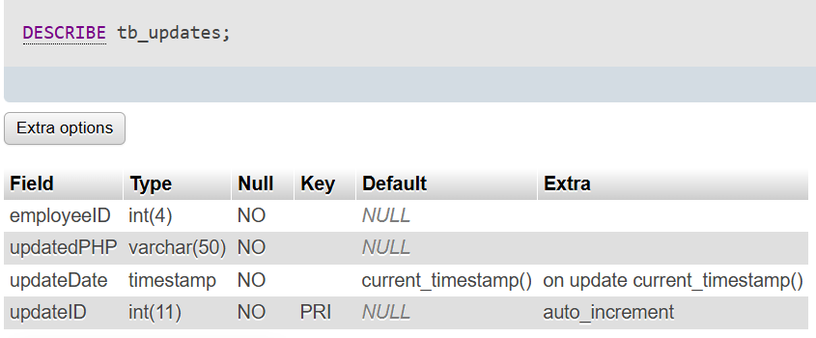

2. ALTER TABLE tb_updates
ADD COLUMN updateStatus ENUM('pending', 'completed', 'failed') DEFAULT 'pending';
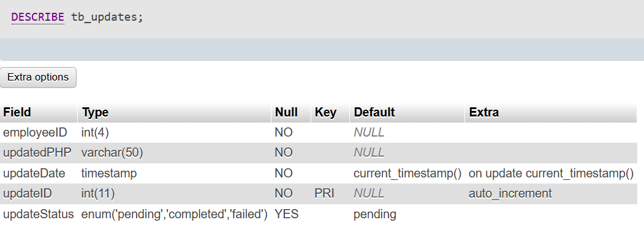

3. INSERT INTO tb_updates (employeeID, updatedPHP, updateDate)
VALUES (?, ?, CURRENT_TIMESTAMP);
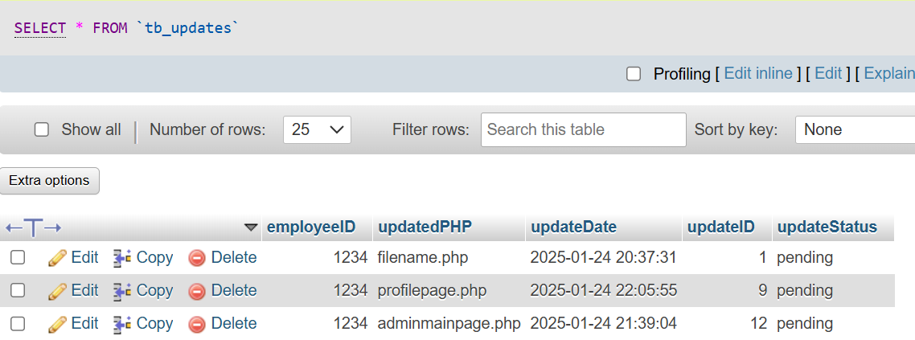

4. UPDATE tb_issueUpdate
SET resolutionStatus = 'Resolved'
WHERE diagnosticID = ?;
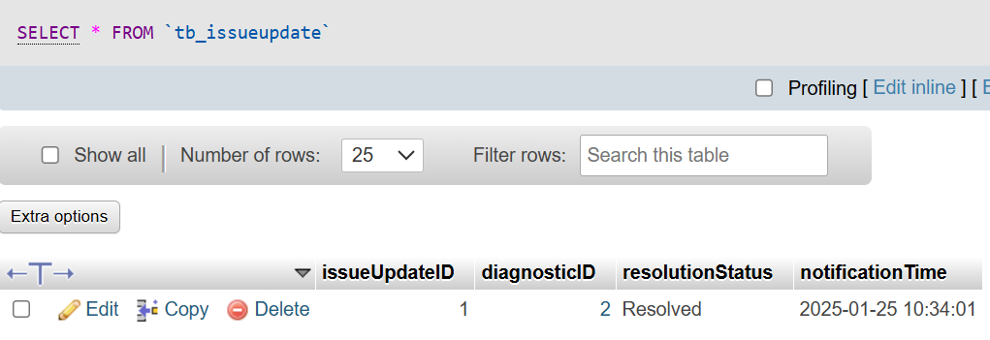

5. SELECT * FROM tb_updates
ORDER BY updateDate DESC
LIMIT 1;


6. SELECT sd.*, iu.resolutionStatus, iu.notificationTime
FROM tb_systemDiagnostics sd
LEFT JOIN tb_issueUpdate iu ON sd.diagnosticID = iu.diagnosticID
ORDER BY sd.issueTime DESC;



5. INSERT INTO tb_issueUpdate
(diagnosticID, resolutionStatus, notificationTime)
VALUES (?, 'Pending', CURRENT_TIMESTAMP);


6. SELECT e.employeeID, u.updatedPHP, u.updateDate
FROM tb_employee e
INNER JOIN tb_updates u ON e.employeeID = u.employeeID
WHERE e.role = 'admin';
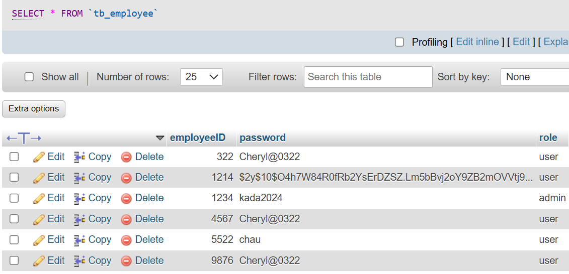


7. SELECT sd.*, e.employeeName, iu.resolutionStatus
FROM tb_systemDiagnostics sd
LEFT JOIN tb_employee e ON sd.employeeID = e.employeeID
LEFT JOIN tb_issueUpdate iu ON sd.diagnosticID = iu.diagnosticID
WHERE sd.issueTime > DATE_SUB(NOW(), INTERVAL 24 HOUR)
ORDER BY sd.issueTime DESC;


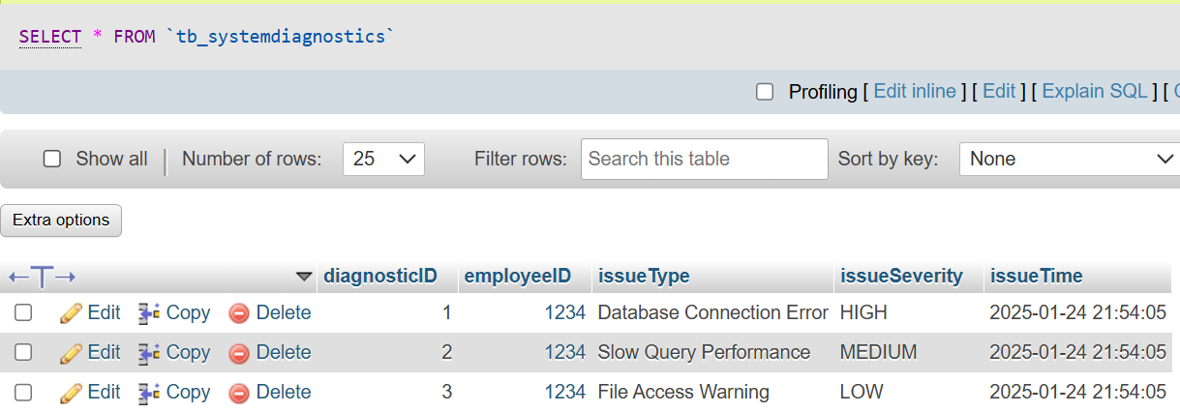


8. DELETE FROM tb_systemDiagnostics
WHERE issueTime < DATE_SUB(NOW(), INTERVAL 30 DAY);

*delete row for tb_systemDiagnostics

3.2 Interface Implementation

Better Loan Application Form to Guide Member

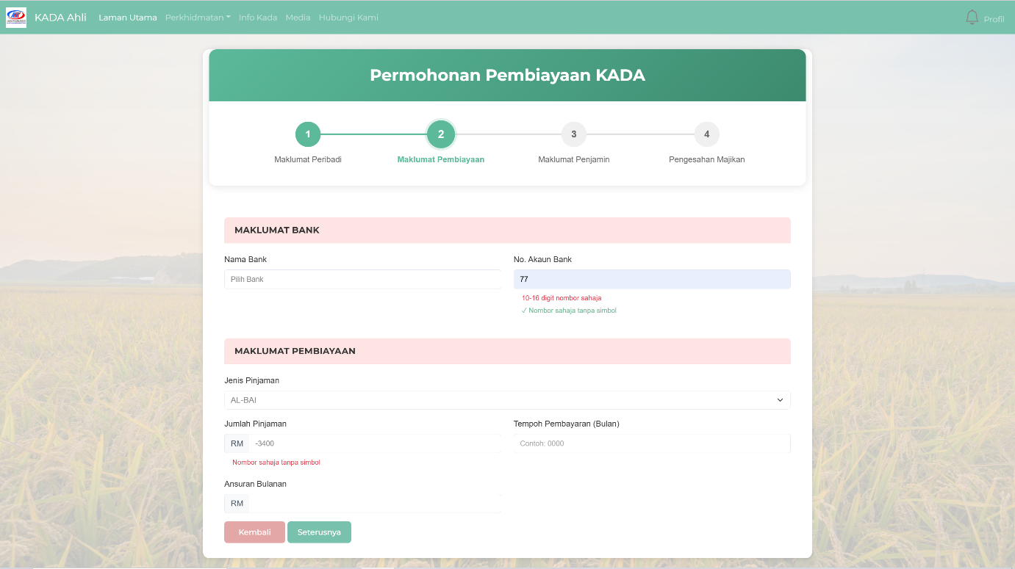

Notification page
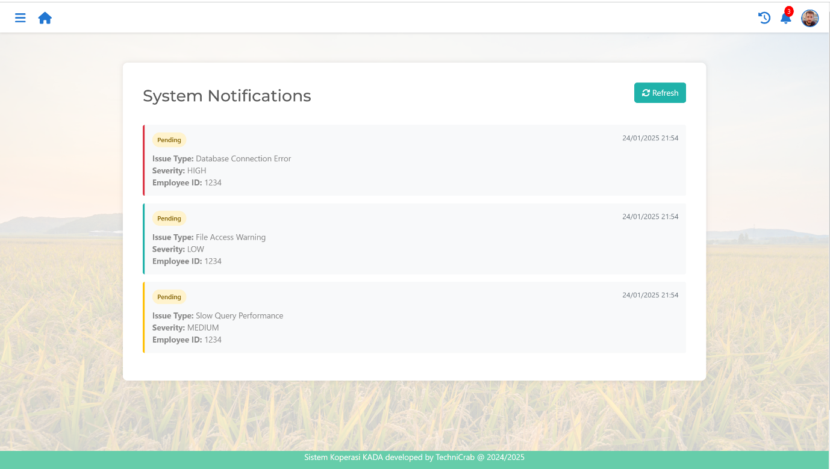

Updated File History page
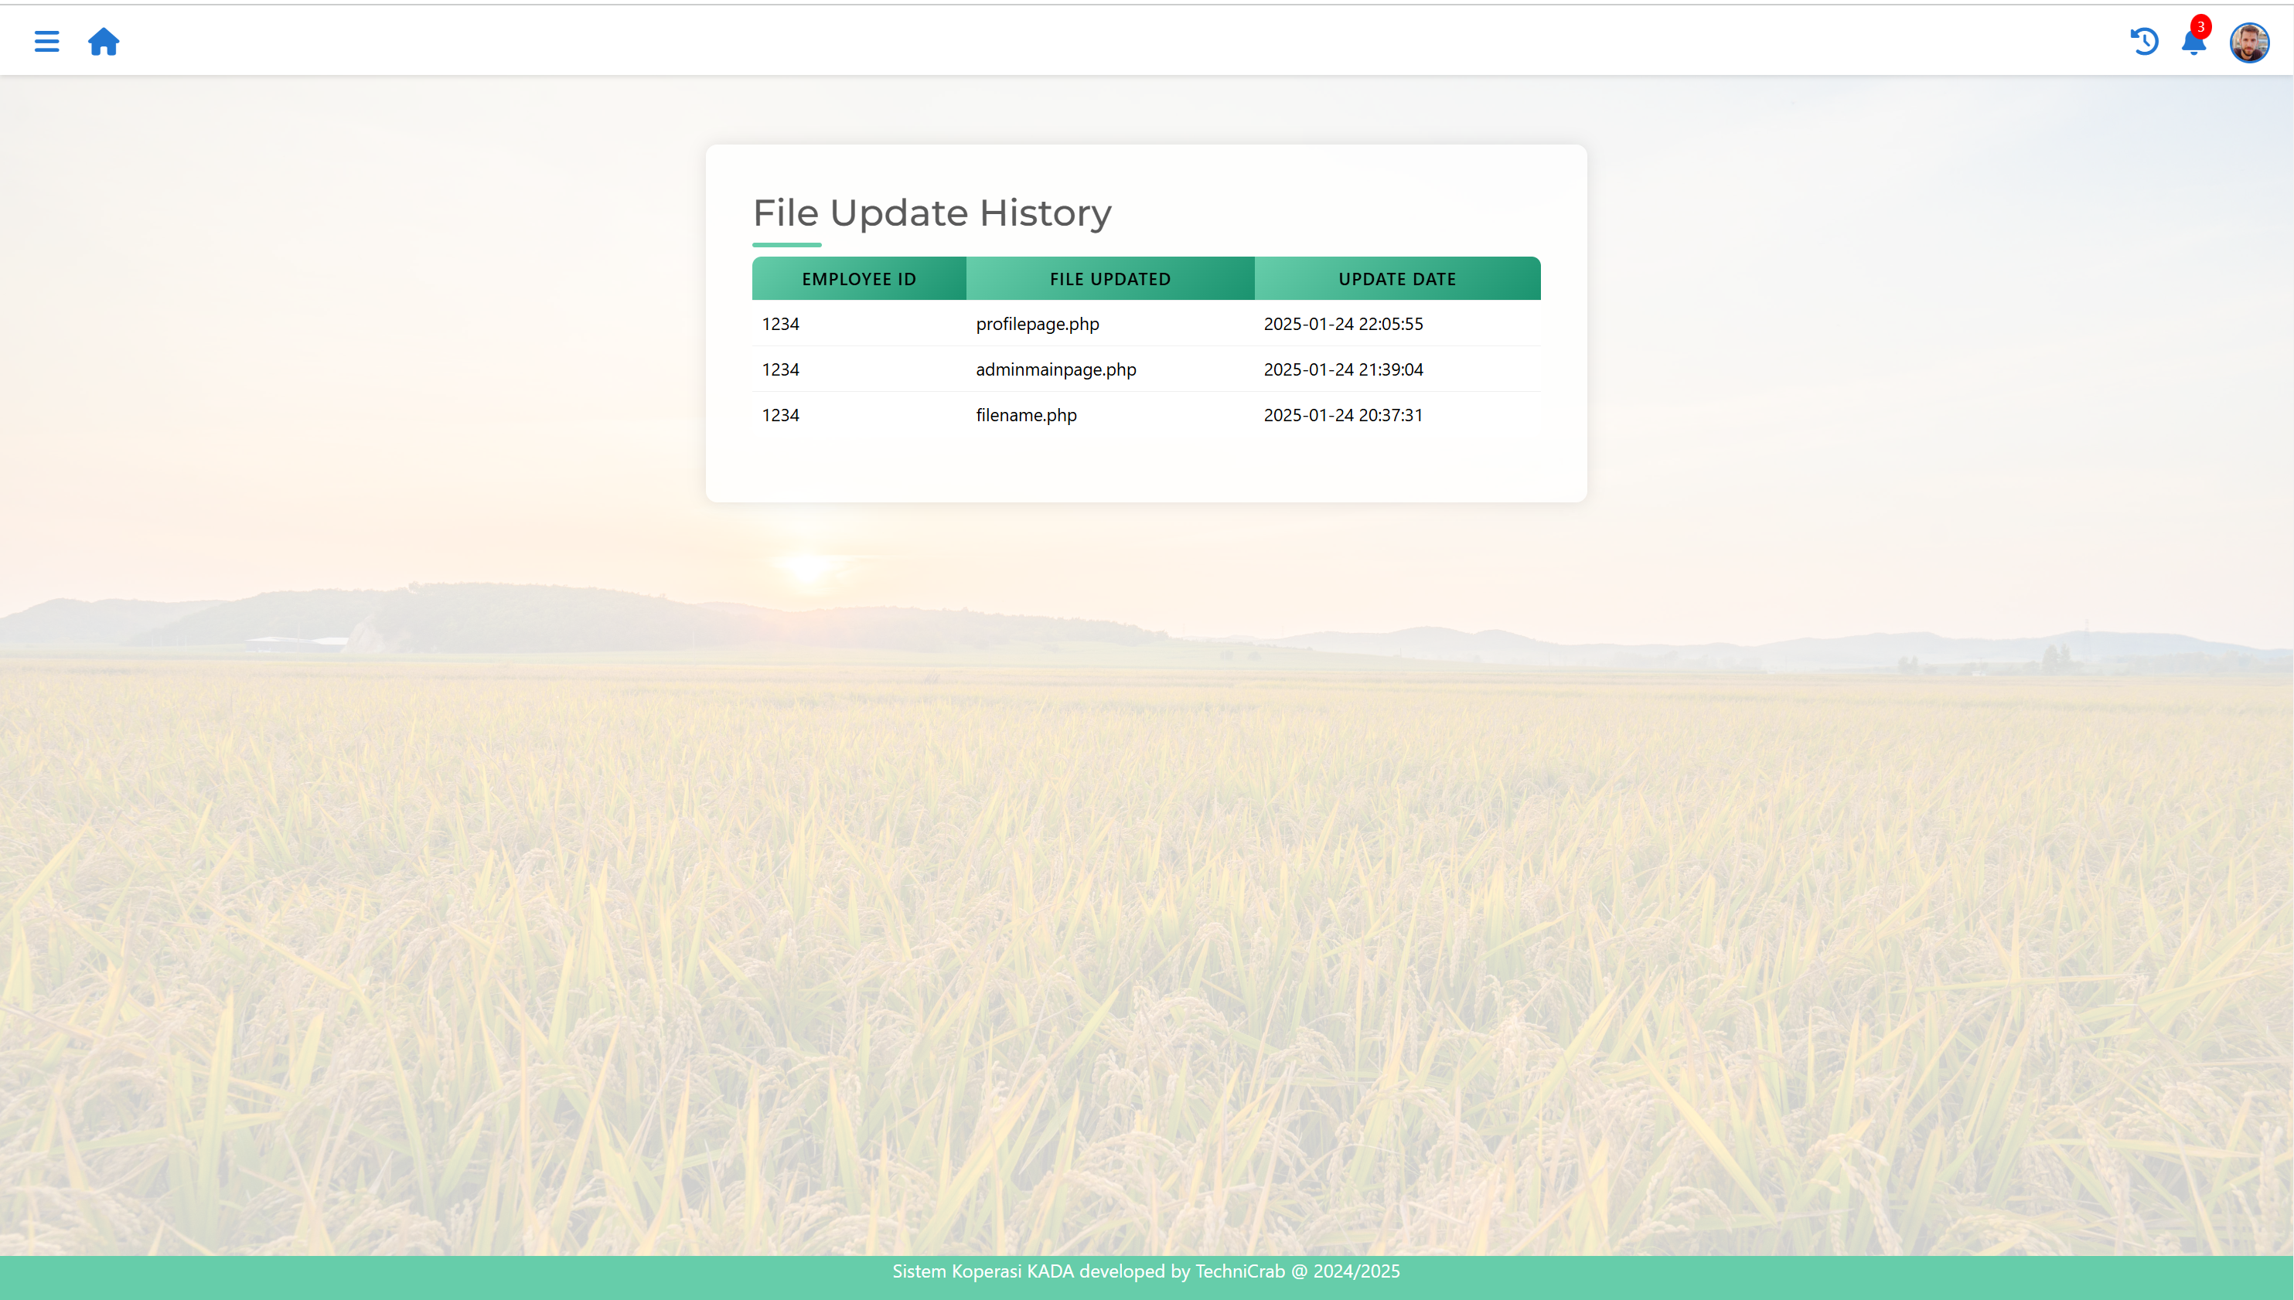

4.1 Conclusion

The main purpose of the System Improvement and Optimization Module is to ensure the best user experience on our website. We strive to eliminate errors, confusing interfaces, lack of guidance, or any other issues users may encounter. There must be an admin to continuously monitor and improve the system, making optimizations and future enhancements as needed. This system must be modified and updated over time to meet the evolving requirements of Koperasi Kakitangan KADA Kelantan Berhad.

My proposed module presents a better, more organized, and user-friendly interface. Users can easily navigate through our website and the loan application form has been reformatted to provide clearer instructions and intuitive controls.

By implementing this module, administrators can easily track and review updated or edited files. When any errors appear, they are immediately been informed through the notification for debugging. This module optimizes the system for both better user experience and improved administrative management. In the future, I hope we can implement more functions and introduce more feature for both the admins and members of Koperasi Kakitangan KADA Kelantan Berhad. For instance, features like ai chat for knowing the details about loan applications or maybe auto-validating and approval for member’s loan application.

4.2 Reflection

This WBL project has been an remarkable learning experience for me. Our journey began in Year 1, Semester 2, it is the first time we were involved in a real company project. We were tasked to develop a fully functional and usable system for our client, Koperasi Kakitangan KADA Kelantan Berhad. The project required us to implement key features such as member registration, loan application, and managing members' financial transaction statuses through a website. To achieve this, we had to engage directly with our client to understand their requirements and expectations while preparing all necessary documents, as well as planning, designing, prototyping, and testing. Our team was divided into groups, and each member contributed significantly to the system's development.

Now that the system development has nearly comes to an end, I can confidently say it has been more challenging, time-consuming, and complex than I initially expected. However, I thoroughly enjoyed the journey and gained valuable knowledge and skills along the way. I am always grateful for studying in the Data Engineering course, which provides more hands-on, practical experiences compared to other programs. This project allowed me to apply theoretical concepts and exposed me to various software engineering skills. I feel fortunate to have worked with such supportive teammates who collaborated effectively to bring this project to life. We have supported each other throughout these two semesters, and I truly appreciate having them as my groupmates.

The experience of working on this WBL project has been a mix of challenges and rewards. On the positive side, it provided invaluable real-world experience, allowing me to apply theoretical knowledge to develop a usable system for our client. However, challenges such as time constraints, debugging errors, and balancing coursework plus stress, while client communication sometimes required extra effort to clarify expectations. These experiences taught me patience, resilience, and the importance of effective teamwork, time allocating and feedback. Client input played a crucial role in refining our work, highlighting the need for detailed requirements gathering and regular updates. Despite the difficulties, this project has been an immensely rewarding journey that strengthened my technical and overall skills, preparing me for future real-world challenges.

I chose to reflect on this because this semester has been exceptionally busy for me. I am genuinely proud of myself for successfully completing all these tasks alongside my other coursework and activities. Moving forward, I plan to reduce my involvement in extra activities and programs so I can dedicate more time to my academics. Balancing so many commitments has been challenging, and I realize the importance of prioritizing my studies to perform better in coursework and exams. My goal is to become a successful IT professional, not someone hindered by constant exhaustion due to insufficient rest.

Through this experience, I have discovered the importance of time management, teamwork, and adaptability especially when working on a real-world project. I learned how crucial it is to gather clear requirements, communicate effectively with clients, and handle unforeseen challenges, such as debugging and time constraints. This project also highlighted the value of hands-on practice in applying theoretical concepts, which significantly enhanced my technical and problem-solving skills. However, I still wonder how I can better balance multiple commitments without compromising on quality or rest.

Moving forward, I plan to prioritize my academics by limiting extra activities and allocating time more effectively to meet deadlines without unnecessary stress. I will seek support from teammates and mentors when needed, as their guidance has been invaluable in this journey. To further improve, I will explore tools and resources for better project management and time optimization to ensure future projects are handled more efficiently and with greater focus on both quality and personal well-being.

